**Chapter 2**

**Review of Literature**

**2.1 Literature Survey 01**

DEVELOPMENT OF ROBOTIC ARM USING ARDUINO UNO

**2.1.1 Introduction**

This proposed work is an overview of how we can make use of servo motor to make joints of a robotic arm and control it using potentiometer. Arduino UNO board is programmed to control the servo motors and Arduino’s analog input is given to potentiometer. This modelling resembles like a robotic crane or we can convert it into robotic crane using some tweaks. Robotic arm is one of the major projects in today automation industries. Robotic arm is part of the mechatronic industry today’s fast-growing industry. This project is a pick and place robotic arm. On large scale it can be used as in environment, which is either hazardous (e.g. radiation) or not accessible. As the size of the robots scale down, the physics that governs the mode of operation, power delivery, and control change dramatically, restricting how these devices operate This also include it's characteristics like its extension, positioning, orientation, tools and object it can carry. This paper is on how we can make robotic arm with non-useful materials and its application for small purposes.

**2.1.2 Block Diagram**

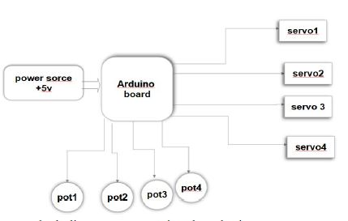

Fig. 2.1 Block Diagram of robotic arm using Arduino

**2.1.3 Advantages and Disadvantages**

Advantages

* Grasping and holding objects and then move them to a new location, or mixing with other
* fluids. (used in laboratories that trust such arms to work within a toxic environment and so do not endanger the researcher. Building cars.
* Retrieving suspicious objects without endangering humans.
* Dig trenches.
* A source of entertainment and education.
* An appendage of an anthropocentric robot.
* Used in surgery.
* Used in farming.

Disadvantages:

* This project is a small-scale production it can pick up only small and lighter objects.
* On large scale this project may become costly and its circuit complexity increases.
* On large scale may become hazardous due to uncontrollable robotic arm it can harm
* physically.

**2.2 Literature Survey 02**

Robotics Controller: A Literature Survey

**2.2.1 Introduction**

The Early Years of Robotics was largely focused on manipulator arms and simple factory automation tasks; materials handling, welding, painting. Cost of computation, lack of good sensors, and lack of fundamental understanding of robot control were the primary barriers to progress. But Robotics today is a much richer field with far-ranging applications e.g. Robots are exploring Mars. The complexities of Robotic systems are increasing day by day as more and more intelligence is embedded into their controllers. Robotic controller is one of the most vital components which defines the accuracy and repeatability of a robot. It is used to modify the behavior of the physical system according to the input value through computations and actuations.

**2.2.2 Advantages and Disadvantages**

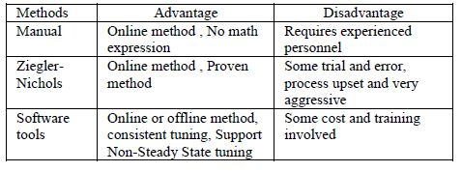

**2.3 Literature Survey 3**

Survey on Robotic Arm Controlling Technique

**2.3.1 Introduction**

Robotic arm is a mechanical arm to perform the desired task. In today’s world there is an increasing need to create artificial arms for different inhuman situations where human interaction is difficult or impossible. Humans pick things up without thinking about the steps involved. So, the robotic arm is controlled manually by using wired and wireless.

The robot industry penetrates a phase of rapid growth. Many institutions introduce programs and courses in robotics. Robotics courses are spread across mechanical engineering, electrical engineering, and computer science departments. A robot manipulator consists of links connected by joints. The links of the manipulator can be considered to form a kinematic chain. The business end of the kinematic chain of the schemer is called the end effector and it is analogous to the human hand. The end effector can be a gripper or can be designed to perform any desired task such as welding, painting, assembly, etc. An end-effector is a tool or gripping mechanism attached to the end of a robot arm used to make intentional contact with an object or to produce the robot’s final effect on its surroundings to accomplish some task. Tools are used in applications where the robot must perform some processing operation on the work-part. In each case the robot must not only control the corresponding position of the tool with respect to the work as a function of time, it must also control the operation of the tool.

**2.3.2 Conclusion**

From the above discussion to conclude the robotic arm controller is a very important factor in the industry. We presented the robotic arm controller by using microcontroller, Accelerometer, remote vision, Man Machine Interface. Even though they have several drawbacks during the control process. So, in my future the new methods are proposed to control the robotic arm using web application and mobile application using ePC platform.